1-Network Topologies

What Is Network Topologies?
# Source: Chatgpt (GPT‑5 Mini) at [12/18/2025]
Network topologies describe the structure of a network — how devices (like computers, switches, and routers) are connected and how data flows between them.
There are two types of topologies:
- Physical Topology: The actual physical connections (wires, devices, etc.)
- Logical Topology: The virtual flow of data regardless of physical layout

🧠 Simple Definition:
# Source: Chatgpt (GPT‑5 Mini) at [12/18/2025]
A network topology is the shape or design of a network — how the devices are laid out and communicate with one another.

🧭 Common Types of Network Topologies:
# Source: Chatgpt (GPT‑5 Mini) at [12/18/2025]
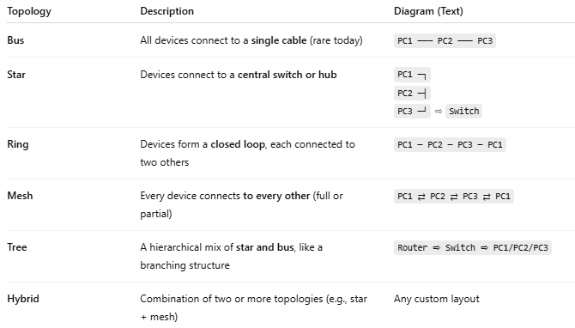

Topology | Description | Diagram (Text)
Bus | All devices connect to a single cable (rare today) | PC1 ─── PC2 ─── PC3
Star | Devices connect to a central switch or hub | PC1 ─┐PC2 ─┤PC3 ─┘ ⇨ Switch
Ring | Devices form a closed loop, each connected to two others | PC1 ─ PC2 ─ PC3 ─ PC1
Mesh | Every device connects to every other (full or partial) | PC1 ⇄ PC2 ⇄ PC3 ⇄ PC1
Tree | A hierarchical mix of star and bus, like a branching structure | Router ⇨ Switch ⇨ PC1/PC2/PC3
Hybrid | Combination of two or more topologies (e.g., star + mesh) | Any custom layout

📊 Comparison of Topologies
# Source: Chatgpt (GPT‑5 Mini) at [12/18/2025]
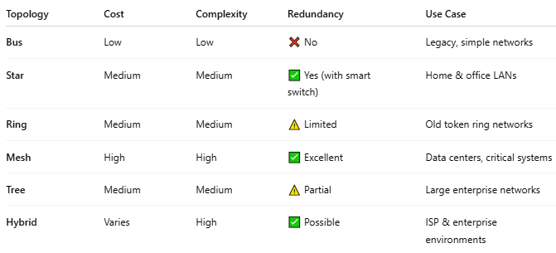

Topology | Cost | Complexity | Redundancy | Use Case
Bus | Low | Low | ❌ No | Legacy, simple networks
Star | Medium | Medium | ✅ Yes (with smart switch) | Home & office LANs
Ring | Medium | Medium | ⚠️ Limited | Old token ring networks
Mesh | High | High | ✅ Excellent | Data centers, critical systems
Tree | Medium | Medium | ⚠️ Partial | Large enterprise networks
Hybrid | Varies | High | ✅ Possible | ISP & enterprise environments

🎯 Why Network Topology Matters
# Source: Chatgpt (GPT‑5 Mini) at [12/18/2025]
- 🧩 Design clarity — visualizes how devices interconnect
- 🛠️ Troubleshooting — makes fault isolation easier
- 🚀 Performance — impacts speed and fault tolerance
- 📈 Scalability — affects how easily you can grow the network

✅ Summary
# Source: Chatgpt (GPT‑5 Mini) at [12/18/2025]

Term | Description
Network Topology | Layout of network devices & communication paths
Types | Bus, Star, Ring, Mesh, Tree, Hybrid
Importance | Impacts performance, reliability, cost

2-Network Layout

What Is Network Layout?
# Source: Chatgpt (GPT‑5 Mini) at [12/18/2025]
A network layout (also called network topology layout) is the physical or logical arrangement of computers, networking devices (routers, switches, etc.), and cables in a network.

🧠 Simple Definition:
# Source: Chatgpt (GPT‑5 Mini) at [12/18/2025]
A network layout is a map or design that shows how devices are positioned and how they communicate within a network.

🧭 Two Main Types of Layouts:
# Source: Chatgpt (GPT‑5 Mini) at [12/18/2025]
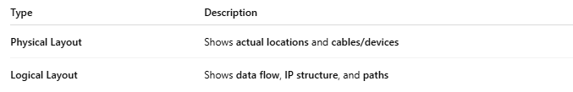
Type | Description
Physical Layout | Shows actual locations and cables/devices
Logical Layout | Shows data flow, IP structure, and paths

📊 Example: Physical vs Logical Layout
# Source: Chatgpt (GPT‑5 Mini) at [12/18/2025]
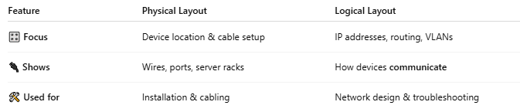

Feature | Physical Layout | Logical Layout
🎛️ Focus | Device location & cable setup | IP addresses, routing, VLANs
🔌 Shows | Wires, ports, server racks | How devices communicate
🛠️ Used for | Installation & cabling | Network design & troubleshooting

🗺️ Examples of Layout Styles (Topologies)
# Source: Chatgpt (GPT‑5 Mini) at [12/18/2025]
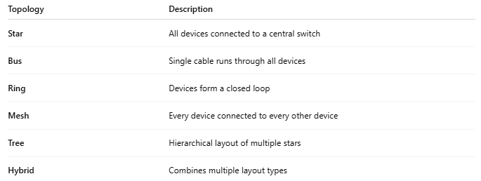

Topology | Description
Star | All devices connected to a central switch
Bus | Single cable runs through all devices
Ring | Devices form a closed loop
Mesh | Every device connected to every other device
Tree | Hierarchical layout of multiple stars
Hybrid | Combines multiple layout types

📥 Why Network Layouts Matter
# Source: Chatgpt (GPT‑5 Mini) at [12/18/2025]


Benefit | Purpose
🧩 Visualization | Understand the network’s structure
🔍 Troubleshooting | Find and fix issues faster
⚙️ Scalability | Helps plan for adding devices/servers
🔒 Security Planning | Helps place firewalls and monitoring tools

⚖️ network layout vs network topology
# Source: Chatgpt (GPT‑5 Mini) at [12/18/2025]
🔑 Key Difference (Short Answer)
- Network Layout → A broad concept that shows the overall design of a network
- Network Topology → A specific part of the network layout that describes how devices are connected
👉 Topology is included within the layout, but layout is more comprehensive.

🧩 Clear Comparison
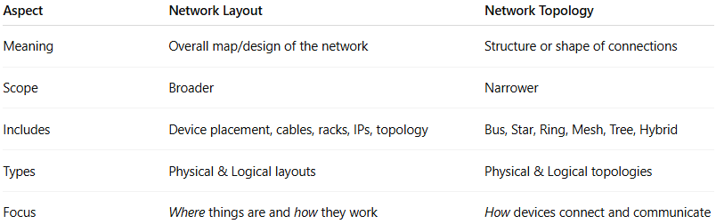
Aspect | Network Layout | Network Topology
Meaning | Overall map/design of the network | Structure or shape of connections
Scope | Broader | Narrower
Includes | Device placement, cables, racks, IPs, topology | Bus, Star, Ring, Mesh, Tree, Hybrid
Types | Physical & Logical layouts | Physical & Logical topologies
Focus | Where things are and how they work | How devices connect and communicate

🧠 Simple Way to Remember
- Network Layout = Complete building plan 🏢
- Network Topology = Hallway and room connection design 🚪
You can’t fully describe a network layout without mentioning its topology.

📌 Example
An office network may have:
- Layout:
  - Servers in the server room
  - Switches in racks
  - Wireless access points on each floor
  - IP addressing and VLANs
- Topology:
  - Star topology on each floor
  - Tree topology across the building
✔️ The topology explains the structure
✔️ The layout explains the whole network

✅ Final Conclusion
Network layout ≠ network topology
🔹 Topology is a component of layout
🔹 Layout is the complete network design
If you want, I can also give a 1-sentence exam answer or a diagram-based explanation.

✅ Summary
# Source: Chatgpt (GPT‑5 Mini) at [12/18/2025]


Term | Network Layout
Shows | Device arrangement and connection methods
Types | Physical and Logical
Used By | Network engineers, admins, IT planners
Purpose | Design, install, secure, and troubleshoot

